Hobby Horse Hill
Therapeutic Equestrian Center
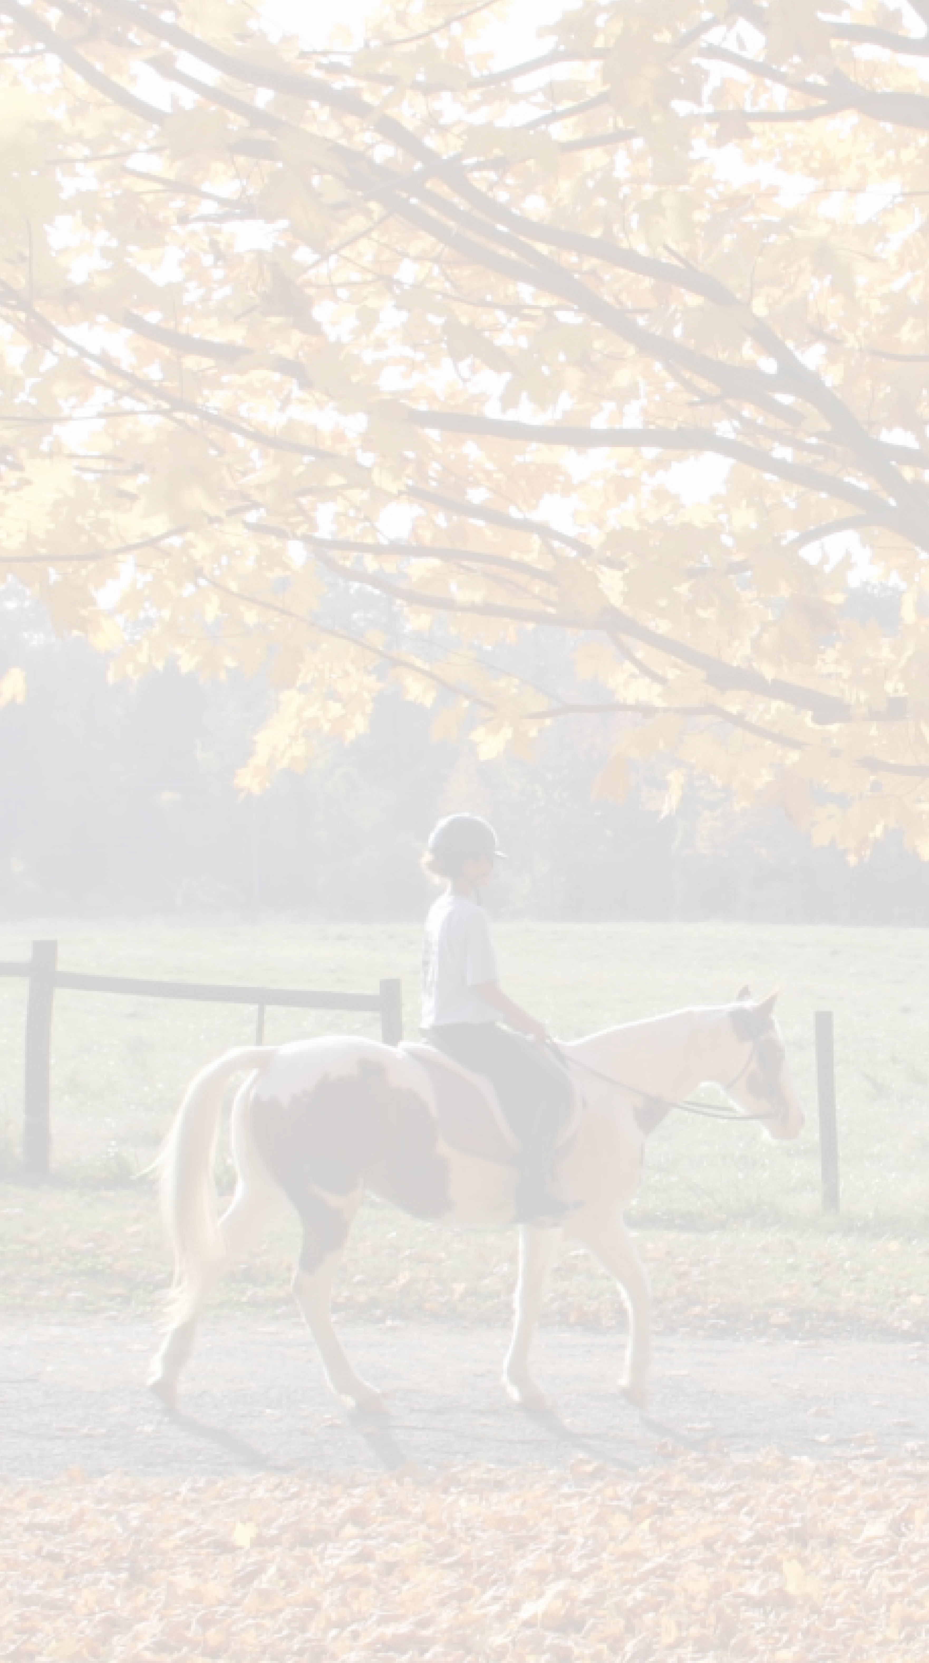
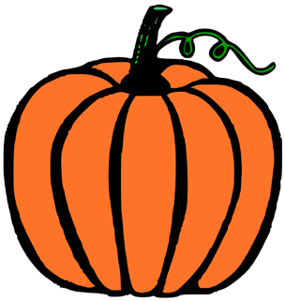
HalloweeN Fall Festival

• Free Pony Rides
• Pumpkin Painting
• Face Painting
Food & Treats

- Costumes Encouraged!
Saturday, October 27 7559 Yankee Street
12:00 pm - 2:00 pm Fredericktown, Ohio
JOIN US FOR THE FUN!

